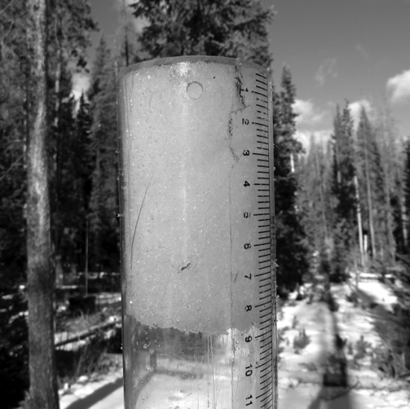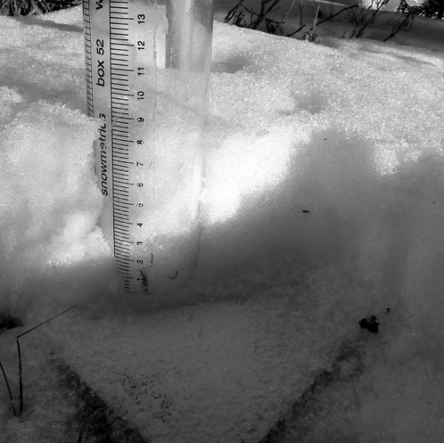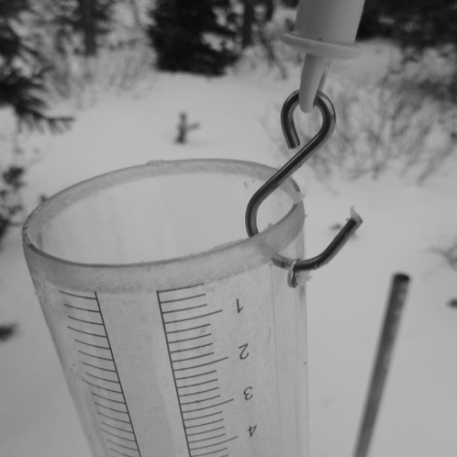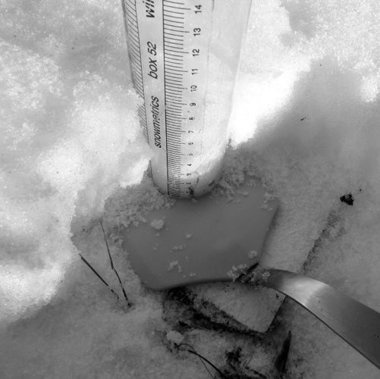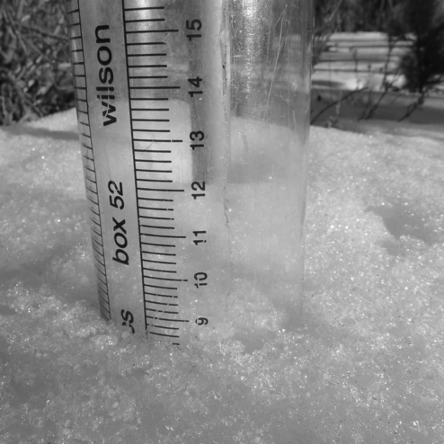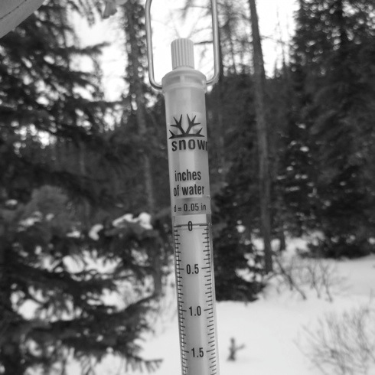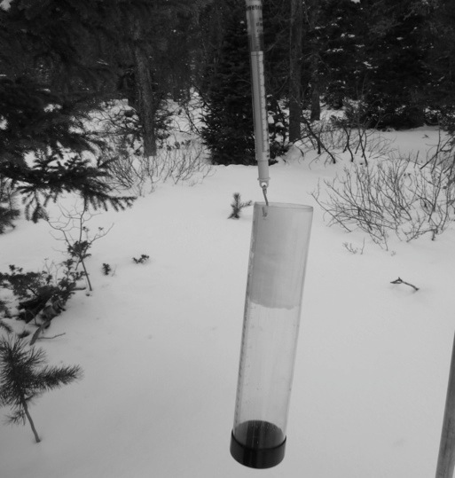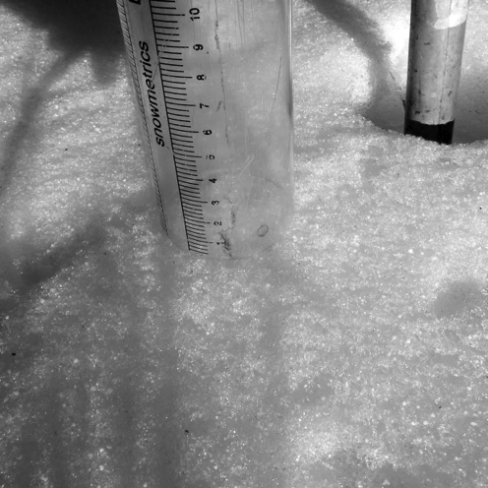

Directions for sampling SWE with a snow board sampler

1. Make sure tube is cold.

2. Remove one end cap.

4. Hold the tube vertically and push from the snow surface down to the snowboard.

3. Tare the scale.

5. Measure and record

the snow depth.

6. Scrape the snow from

one side of the tube.

7. Slide the spatula

under the tube.

8. Lift the spatula and the tube and turn the tube upside down.

9. Place the scale hook

in the hole on the tube.

11. Carefully dump the snow out of the tube and repeat.

10. Weigh the tube.

Record the SWE.

**Snow Board Sampler – Tips for Use**

Keep the tube cool. Use gloves and do not carry the tube inside your parka. This will help the snow slide in and out without sticking.

If snow does stick inside the tube after a measurement, tap the tube gently to remove, or reach in with a gloved finger and wipe if the snow is close to the tube end.

Do not whack the tube on a hard object. Although it is special plastic tubing designed for exceptional strength, it will crack or break if impacted too hard, especially if it is cold.

If you cannot get all the snow out of the tube between measurements, re-tare the scale so that your measurement is accurate.

Be sure to wipe all the snow off the outside of the tube before measuring. Even a little bit of extra snow will produce an error in your measurement since the scale is very accurate.

Hold the scale by the chord when measuring SWE, not by the scale itself. This will keep the scale moving freely and give an accurate result.

Both the tube and scale have metric and English units. Be sure you are using the same units when reading the depth from the tube and the water equivalent from the scale!

After finishing your measurement, clean the board off completely and place it back on the snow surface.

To calculate snow density, divide the snow water equivalence (mm) by the snow depth (cm), and multiply by 10. This will give percent density. For example: 10 mm SWE with 20 cm depth = (10/20) x10 = 5%

For English units, divide SWE (in tenths of inches) by snow depth (in inches), and multiply by 10.

For example: 0.65 inches of SWE divided by 8.2 inches depth = (0.65/8.2) x100 = 7.9% or 8%